1. Plot the following function

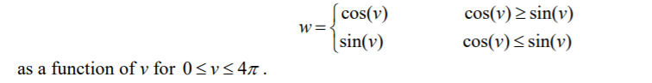

1. Using matrix theory in MatLab, solve the following system of linear equations.

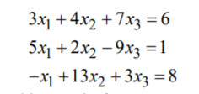

1. Write a MatLab code to check whether the following functions are linearly independent.

sin(x), cos(x), exp(x), for x>0.

1. Try to minimize the number of command prompt in the script as much as possible.

